GURU NANAK DEV UNIVERSITY, AMRITSAR

DEPARTMENT OF ELECTRONICS TECHNOLOGY

AUTOMATIC LAWN ROVER WITH PLANTATION AND IRRIGATION SYSTEM

SUBMITTED BY:
NAME = GURNOORPREET SINGH
ROLL NO = 17042100359
E-MAIL = gurnoorjanjua0987@gmail.com

NAME = SATISH KUMAR
ROLL NO = 17042100367
E-MAIL = satishkumar75890@gmail.com

NAME = ANKIT SHANGARI
ROLL NO = 17042100338
E-MAIL = ankit26022004@gmail.com

Abstract
This is the prototype of the AUTOMATIC LAWN MOWER AND IRRIGATION SYSTEM which is mainly used in grounding grass and irrigating seeds and plants. This prototype consists of Arduino nano, motor driver L293D, rely module, Bluetooth module (HC-05), Gear motors, DC motors, etc.
The Automatic Lawn Mower represents a groundbreaking innovation in the realm of lawn care technology. This autonomous device offers a revolutionary approach to maintaining lawns by eliminating the need for manual labor traditionally associated with mowing. Equipped with state-of-the-art sensors and navigation systems, the automatic lawn mower efficiently navigates outdoor spaces.
The benefits of the automatic lawn mower extend beyond convenience, as it also promotes the health and aesthetics of the lawn. By maintaining consistent mowing patterns and cutting grass at optimal heights, the device encourages healthy grass growth and minimizes the risk of lawn diseases.

Introduction
An automatic lawn mower and irrigation system is a compact and handheld device designed to cut lawn grass and irrigation systems for watering plants. In the realm of modern landscaping, the integration of technology has revolutionized the way we approach lawn maintenance. Traditional methods of manual mowing and irrigation are being replaced by automated systems that offer convenience, efficiency, and sustainability. Among these innovations stands the Automatic Lawn Mower and Irrigation System (ALMIS), a pioneering solution designed to streamline lawn care processes while maximizing the health and beauty of outdoor spaces.

Objective
The objective of this project is to design, develop, and implement an automatic lawn mower system that utilizes advanced robotics and sensor technologies to autonomously mow lawns. The project aims to create a reliable and efficient solution that reduces the need for manual labour in lawn maintenance while promoting the aesthetic appeal of the lawn. Key objectives include:
1. Designing a sensor-based platform capable of navigating outdoor environments and efficiently mowing grass.
2. Implementing programmable scheduling features to allow users to customize mowing times.
3. Developing a user-friendly interface for remote monitoring and control of the automatic lawn mower.
Overall, the project aims to deliver a cutting-edge solution that simplifies lawn maintenance, enhances convenience for users, and contributes to sustainable landscaping practices.
Technology stack
The Technology stack used in this prototype is:
1. Arduino nano
2. Gear motors
3. Bluetooth (HC-05)
4. 2 Channel relay module
5. Motor Driver L293D
6. High rpm DC Motor
7. Jumper Wires
8. Battery (Lithium 3.7V)
1: Arduino Nano
The Arduino Nano is a compact and versatile microcontroller board based on the ATmega328P chip, similar to the Arduino Uno but with a smaller form factor. It features a USB interface for easy programming and communication with a computer, making it suitable for a wide range of projects, from simple prototypes to more complex embedded systems.

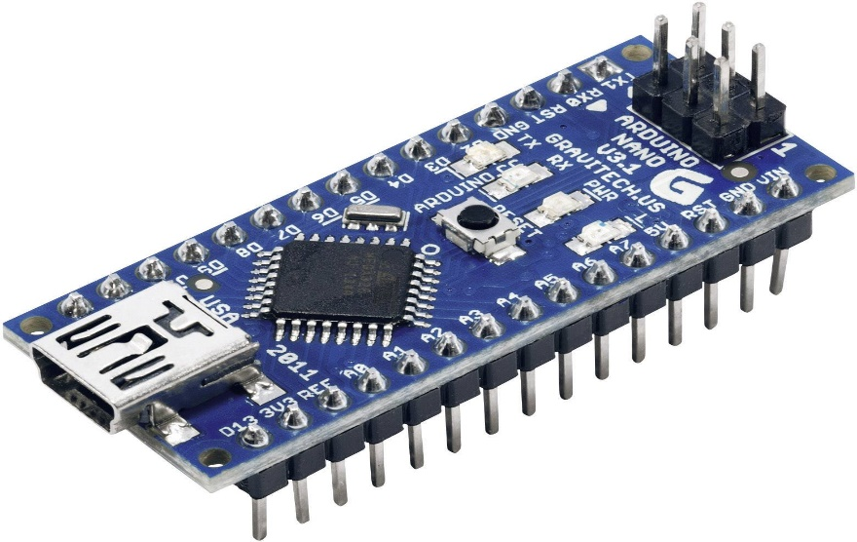

Overall, the Arduino Nano is a versatile and compact microcontroller board that offers a wide range of features and capabilities for makers, hobbyists, and professionals alike. Its small size, integrated USB interface, and compatibility with the Arduino ecosystem make it an ideal choice for various embedded projects and prototyping applications.
2: Gear Motor
Gear motors are a fundamental component in many mechanical systems, offering a combination of motor power and gear reduction in a single package. They are widely used across various industries for their ability to efficiently convert electrical energy into mechanical motion while providing torque multiplication through gear reduction.
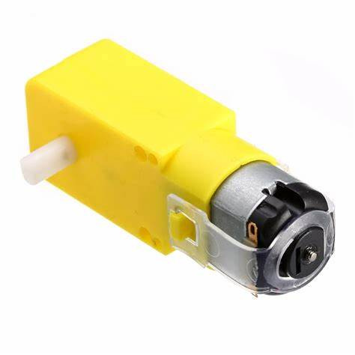

3: Bluetooth (HC-05)
The HC-05 is a commonly used Bluetooth module that enables wireless communication between electronic devices. Here's an introduction to the HC-05 Bluetooth module:
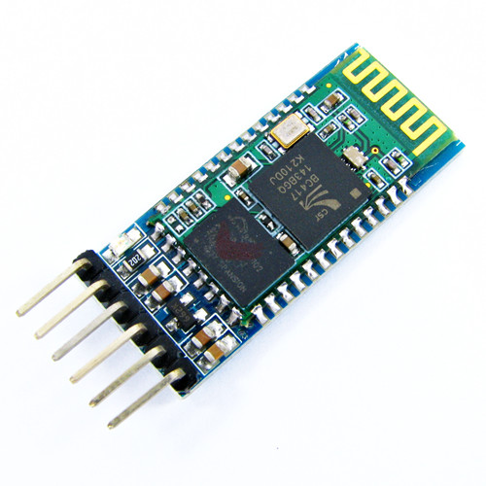
The HC-05 module supports Bluetooth 2.0 (EDR) and provides a serial interface for communication with microcontrollers or other devices. It features a built-in Bluetooth stack, enabling easy integration into various projects. The module typically operates in either Master or Slave mode, allowing it to connect to other Bluetooth devices.

4: 2 Channel relay module
A 2-channel relay module is a device used to control two separate electrical circuits (channels) using low-voltage signals, such as those from a microcontroller or a digital output from another electronic device. Here's an overview of a typical 2-channel relay module:
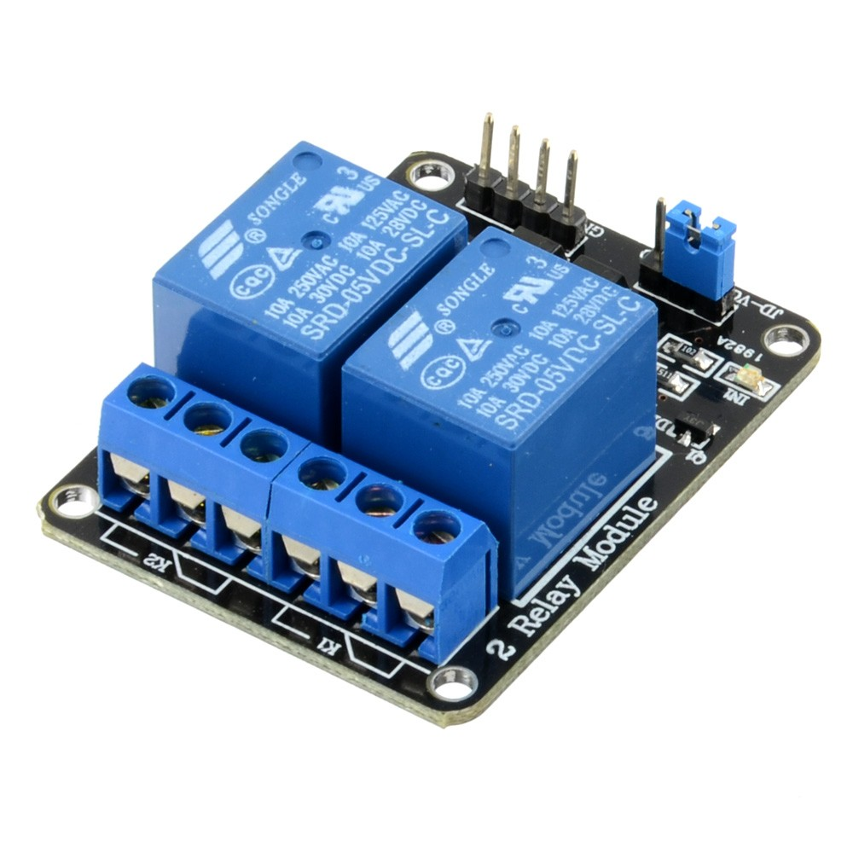

2-channel relay modules are commonly used in various electronic projects and applications, including home automation, robotics, industrial control systems, IoT (Internet of Things) devices, and prototyping. They allow you to switch high-power or high-voltage loads using low-power control signals, providing an interface between digital electronics and electrical appliances or equipment.

5: Motor Driver L293D
In your air quality monitoring system, the LCD (Liquid Crystal Display) plays a crucial role as the primary user interface. Here's a detailed look at its function and use in the project:

### Function of the LCD:
1. *Data Display*: The primary function of the LCD in this project is to display real-time data. It shows the concentrations of various gases detected by the sensors, such as smoke (simulated as SO2), carbon monoxide (CO), and carbon dioxide (CO2). Each gas concentration is presented in a readable format, allowing immediate interpretation of the air quality.

2. *Feedback Interface*: Beyond displaying raw data, the LCD can also provide feedback based on predefined thresholds. For example, if the concentration of any gas exceeds a certain limit, the LCD can display warning messages like "High CO2" or "Unsafe Air Quality."

3. *System Status Indicators*: The LCD can show system statuses such as "System Ready," "Calibrating," or "Error" to give users real-time updates on the system's operational state.

### Use of the LCD in the Project:
1. *Real-Time Monitoring*: The LCD allows users to monitor air quality in real-time without needing any additional devices or interfaces. This instant access to data is vital for assessing environmental conditions quickly and accurately.

2. *User Interaction*: By displaying data continuously, the LCD facilitates user interaction with the monitoring system. Users can see the effectiveness of air purifiers or ventilation changes based on immediate feedback from the LCD.

3. *Educational Tool*: In educational settings, the LCD helps demonstrate how various factors affect air quality. It can be used in classrooms to teach students about environmental science and the importance of air quality.

4. *Portable Monitoring*: In portable versions of the air quality monitor, the LCD is essential for delivering on-the-go readings. It allows the device to be used in various locations, from indoor rooms to outdoor environments, providing versatility in monitoring air quality.

5. *Cost-Effectiveness*: Using an LCD is a cost-effective way to provide a visual output device on the system. It avoids the need for more complex and expensive display technologies or external computer software, reducing the overall system cost.

### Integration with the System:
The LCD in this project is typically connected via an I2C interface, which minimizes the wiring complexity and conserves microcontroller pins for other uses. This setup enhances the modular design of the project, allowing for easy updates and maintenance.

Overall, the LCD enhances the functionality and user-friendliness of the air quality monitoring system, making it accessible and practical for a wide range of users and applications.

Circuit diagram
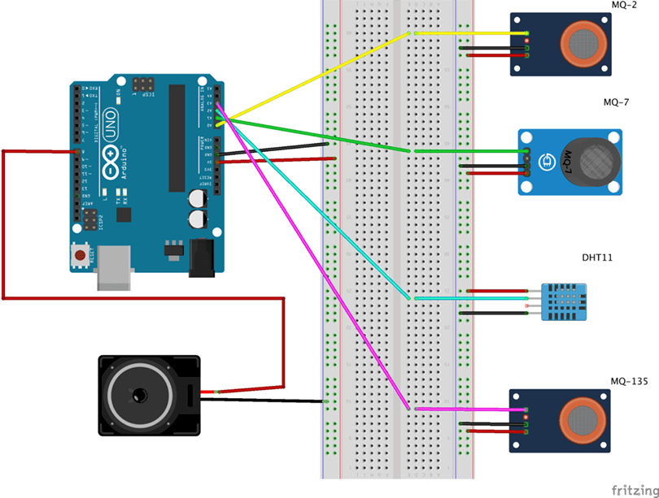
CODE
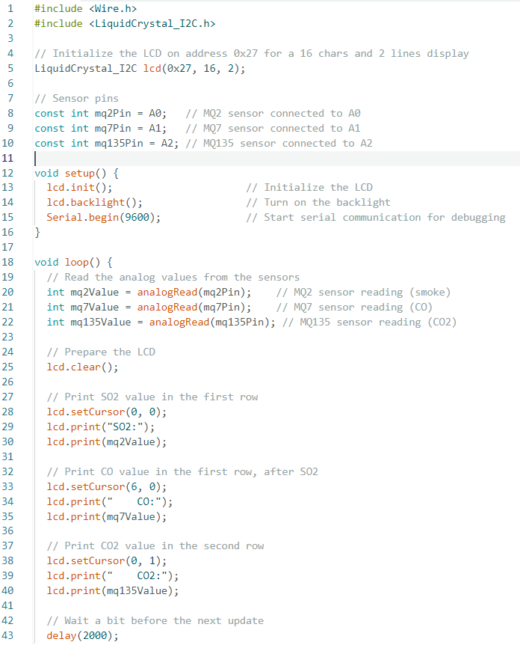
METHODOLOGY
Methodology:
The system utilizes three gas sensors (MQ2, MQ7, and MQ135) connected to an Arduino Uno. The MQ2 sensor is used for detecting smoke, the MQ7 sensor for carbon monoxide, and the MQ135 for carbon dioxide levels in the air. Each sensor's analog output is connected to the Arduino's analog pins. The Arduino processes these readings and displays the values on the LCD. The I2C protocol facilitates communication between the Arduino and the LCD, reducing the complexity of the wiring.

The code for the Arduino is written in C++. It initializes the sensors and LCD, reads the sensor outputs, processes the data, and displays the readings on the LCD. The display shows the concentration of gases detected by each sensor, cycling through the readings every 2 seconds to provide a real-time update of air quality.

Results and Discussion:
The system provides real-time monitoring of air quality by displaying the concentration levels of various gases. This can be used in homes, offices, or industrial areas to continuously monitor air quality. The use of an LCD allows for an immediate and clear display of data, and the portability of the system means it can be installed in various locations.
Conclusion
Portable pollution checkers are valuable tools for monitoring air quality and identifying pollutants in a given environment. They are typically small and lightweight, making them easy to transport and use in a variety of settings, including indoors and outdoors. Portable pollution checkers can detect a wide range of pollutants, including particulate matter, volatile organic compounds, and gases such as carbon monoxide and nitrogen dioxide.
The accuracy of portable pollution checkers can vary, depending on factors such as the quality of the sensors and the calibration of the device. However, many models are highly accurate and can provide real-time data on air quality, allowing individuals and organizations to make informed decisions about their exposure to pollutants.
Overall, portable pollution checkers are valuable tools for promoting public health and raising awareness about the importance of air quality. They can be used by individuals, communities, and governments to monitor pollution levels and take action to reduce emissions and improve air quality.
So this was our project of a prototype of Portable Pollution checker
Thank you…

